**Kernel Master Data – Application Performance Test Report**

**Test Summary:**

|  |  |
| --- | --- |
| Kernel Request | Application |
| Base URL | https://integ.mosip.io |
| Execution Window | 2019/01/16 03:41 PM IST to 2019/01/16 04:02 PM IST |
| Maximum User Load | 100 |
| Tool Used | Jmeter |
| Average Response Time | 7461 |
| Throughput Achieved per sec | 9.6 per sec (Combined) |

Transaction Summary:

|  |  |  |  |  |  |  |  |
| --- | --- | --- | --- | --- | --- | --- | --- |
| Label | #Sample | Average | 90% line(ms) | Min(ms) | Max(ms) | Error% | Throughput/Sec |
| createApplication | 3032 | 25226 | 31527 | 667 | 54528 | 0.26% | 2.45 |
| getAllApplication | 2972 | 1473 | 3322 | 251 | 42114 | 0.54% | 2.39 |
| getApplicationByCodeAndLanguageCode | 2956 | 1299 | 3282 | 95 | 42117 | 0.47% | 2.39 |
| getAllApplicationByLanguageCode | 2944 | 1397 | 2656 | 259 | 42106 | 0.31% | 2.40 |

Response Times Over Time

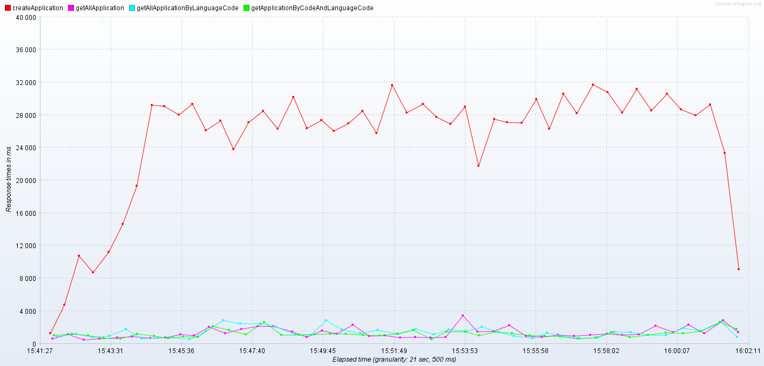

Transactions per Second

